Integrating Diverse Student Devices into the Digital Classroom

Craig Prince
General Exam Report
Dept. of Computer Science and Engineering
University of Washington

January 7, 2007

Abstract
Technology has always promised great things for education, yet despite years of research into classroom computing technology there has been little adoption. Active Learning is a pedagogy that has been shown in general to be a very effective way to teach. One way to promote Active Learning is through the use of Classroom Response Systems (CRSs) – computing systems that allow giving students activities and electronically collecting the results in class. There are two main categories of CRSs, those that focus on rich digital ink input and those that rely on multiple choice or textual responses. I argue that the richer input afforded by digital ink systems is beneficial to education. Because Tablet PCs and other devices supporting digital ink are expensive, people have started exploring the use of handheld and mobile devices in the classroom. However, even these works focus on having a homogeneous set of devices for all students. It is my claim that the most feasible way to deploy CRSs in the classroom is to utilize the mobile devices that students already carry and to develop techniques to successfully integrate a diverse set of devices into the pedagogy developed for using CRSs. I will outline the existing work in the field and propose a set of future work in order to attain this goal.

Introduction
Technology has long promised to transform how people collaborate and communicate with each other. From the earliest days of computers and Doug Englebart’s work at SRI [23] there has been a vision of integrating rich modes of communication together electronically. Today, this vision has come true for many areas of our lives: the way we do business, the way we are entertained, the way we socialize, the way we travel are all influenced greatly by computers; however, there are several areas where technology has made little impact. The classroom is one such domain. While classrooms today have digital projectors and many lectures are based on digital slides, technology has done little to fulfill the promise of transforming the way we teach. There is much evidence showing the potential of computing technology to provide a richer experience to students [4][13]. And so the question remains as to why there has not been more penetration of technology into the classroom?
One broad concern that is often raised when suggesting introducing technology into the classroom is that the technology is not necessary if an instructor simply improves his or her instruction – making it more compelling and including more Active Learning. There are a number of different responses to this concern. First, while it is true that a good teacher can achieve most of the gains supported by classroom technology, the technology can help instructors to follow the best pedagogical practices and can enable interactions not otherwise possible. Also, good teachers are a scarce commodity. A second reason for introducing technology into the classroom is that it can ease the burden on the instructor regardless of his/her skill level. Technology can make the electronic distribution, collection, and aggregation of materials easier [4]. Finally, technology has the potential to allow good teachers to scale their abilities to a larger audience and allow them to reach more people, more easily than with conventional classroom practices [21].
Another concern is that these systems are often very costly and difficult to deploy in a real educational scenario. This is true of most classroom technologies. In addition to the challenge of simply creating and maintaining a robust platform, another deployment issue is the fact that the computing devices need to be set up and distributed to all students before class begins.
I claim that a feasible, long term, self-sustaining solution is to have the students themselves be responsible for bringing their own technology into the classroom – just as they bring pencils, papers, and books to class today. I also claim that the most effective way to use the technology is for supporting Active Learning and engagement of students in the classroom. The question I hope to answer with my work is how then to integrate the diverse set of devices that students already carry with them to class into the Active Learning pedagogy to support student activities in the classroom. Specifically, I hope to address the following issues:
- How to combat envy effects and conflicts amongst students in the classroom who use different devices,
- How to provide rich interaction on devices with limited capabilities; and determine what the limits are for different devices,
- How to design classroom activities for a diverse set of devices,
- How to assist the instructor with dealing with responses from a diverse set of devices, and
- How to evaluate the effectiveness of Classroom Response Systems when there are a diverse set of devices in the classroom.
This paper will begin in section 2 with a brief explanation of Active Learning – the learning theory behind most education today. Then in section 3 I will introduce the concept of a classroom network, explaining the different interaction channels in the classroom and how they are used in Active Learning. This section includes a discussion of how classroom technology fits into the classroom network. Next, section 4 looks at the difference between textual and diagrammatic exercises for Active Learning. Sections 5 and 6 will continue the discussion from section 3 by surveying the different classroom technologies that support Active Learning by putting them into a single unifying framework based on their methods for engaging students. I will argue that the Tablet PC supports a much richer interaction for students than other devices. Finally, sections 7 and 8 of the paper will outline the challenges of dealing with a heterogeneous set of student devices and my proposed work toward meeting these challenges.

Active Learning
Most technology in the classroom is designed to support the Active Learning pedagogy. The goal of this pedagogy is to engage students with the learning process. There are many different ideas about how to engage students in the classroom. I will now examine some of the work done in this field and discuss the value of this work including what it means for technology in the classroom.
Active Learning is a theory of teaching that can be traced back to the days of the great Greek philosophers. In these days it was believed that the most effective way to teach people was to interact directly with them, probing the students with questions and having them think about and come up with the answers themselves. This form of “Socratic teaching” as Abrahamson [3] describes it can be considered the first form of Active Learning. Abrahamson argues that Active Learning is not simply about engaging students with the material, but is focused on helping the students to build mental scaffolding to place their knowledge in and to assist them in unifying their own experiences within this scaffolding. Because the student is constructing his/her knowledge, the theory behind this type of learning is called “constructivism”. The alternative theory, “behaviorism”, believes that students learn by being simple sponges for information; and behaviorism implies that instructors can build the mental models for the students – for example, through lectures.
Active Learning, as the name implies, is an active process in which the learner must assimilate the knowledge given, fitting it into the mental frameworks and ideas already constructed by the learner and also using the new knowledge to build new mental models and structures [57]. These structures cannot simply be created on their own, but must be built upon the observations and models already built by the learner [33]. The easiest way for this to be done is by allowing the learner to actively participate in the lecture.
Many people have examined different methods of helping students to build this mental framework. Scardamalia and Bereiter [48] suggest that one way to help build mental frameworks is to have students generate questions that they would like to have answered about a specific topic. This allows students to learn about the topics they are interested in, keeping them engaged. This technique is also designed to get students to identify those parts of their mental framework that are incomplete. Another approach is proposed by Ploetznerl et al. [44] who suggest that one can learn well by explaining a topic to others. This fits into the Active Learning pedagogy because the authors argue that teaching others requires a person to anticipate the questions of others, requiring him/her to fill in the gaps within his/her knowledge and understanding.
Along these same lines, Mazur [38] suggests that “peer instruction” is a good way to engage students with the material and to help them to learn. Peer instruction has several components: first, there is the idea of student exercises; then there is the notion of discussion with one’s peers; and, finally, there is a resolution phase where the whole class resolves any conflicts and arrives at a final solution. Student exercises are the basis for Classroom Response Systems (CRSs), the main focus of my work. Student exercises are usually given by the instructor to engage the student with the material and allow them to “discover” the solution themselves – similar to the “Socratic teaching” described above.
Active Learning has been shown to be extremely effective at increasing students’ learning outcomes [3][48][57]. One of the best quantitative pieces of evidence for this was shown by Hake [27] . He examined 62 introductory physics courses with over 6000 students and found that those students in classes which were taught using Active Learning methods had learning gains over 2 standard deviations higher than those who attended traditional lecture-based courses.

Technology in the Classroom
Though it would appear that Active Learning is a more effective pedagogy than traditional lecture-based classes, I will now show the role that technology can have within the classroom to support this pedagogy. To do this I will first describe the concept of a classroom network. I will then give a brief overview of the different technologies and associated research that have been used to support the various interactions and components of the classroom network. Finally, I will further expand on the concept of Classroom Response Systems that I introduced above.

Classroom Networks

Public
Display
Instructor
Students
A
A
A
B
B
C
D
Classroom Network
Figure 1. An example of a classroom network. There are three main parties in most classroom networks: the public display, the instructor, and the students. This diagram illustrates various common interactions between these parties. The instructor lectures to students and gets questions and responses from them (A). The students interact amongst themselves (B). The students view slides or text shared via the public display (C). The instructor interacts with the public display by sharing lecture slides and or student-created artifact on the display (D).
Classroom networks are computer-based networks that attempt to mimic the interactions already present within the classroom [42]. These interactions can be supported by technology to enhance the interactions or to make them more efficient. Figure 1 is a diagram which shows the various components of most classrooms and describes how these components interact with each other. The center of the classroom is the instructor and can be a hub for communication. One of the instructor’s roles is to communicate to the students in the classroom as shown by the label (A). The instructor also acts as a mediator for the public display (D). The public display can be a whiteboard or even digitally projected slides. The public display has a central role in the classroom because it acts as a shared communication channel (C) to all students simultaneously [34]. The public display acts as a visual display for information and interaction and persists longer than the instructor’s speech. Finally, student-to-student interaction is central to most classroom networks (B). Student-to-student interaction is also an important for Mazur’s “peer instruction” [38] and many CRSs.
It is interesting to note that all of the interactions just described can take place within classrooms that make no use of computing technology. For example, an instructor can communicate with all students by lecturing to them, students can interact with each other by “turning to his/her neighbor”, and a whiteboard can be used in the same manner as digitally projected slides. However, computing technology can be and has been used to make many of these channels more efficient. Also, as I will show below the technology has been used to augment these channels with additional functionality not otherwise practical or possible.

Technology’s Role in the Classroom
Communication is one of the strengths of technology. Cellular phones give us the ability to always stay in contact with each other verbally, while e-mail and the Internet have also become vital for keeping in touch with one another, meeting new people, and sharing experiences with others. Technology has made communication much easier. Most work on education and technology seems to point out that both verbal and visual in-class communication is still a very important part of learning. However, the communication that technology enables is a third channel that has shown great potential to transform the classroom [51].
Archiving lectures is one area which has been explored using technology. Digital whiteboards make the capture and archiving of lecture material much easier. There are many different digital whiteboards on the market today [8][52]. Some digital whiteboards even allow for the display of, and interaction with, digital content. In a completely digital classroom it is possible to create a record of the lecture for later playback or analysis. The Classroom 2000 project [1] takes this approach. Its goal is to create a complete digital archive of a lecture by recording all the interaction channels of the classroom network. Abowd et al. show how this is feasible through the use of captured audio, video, digital ink, and lecture slides. Abowd then provides tools for linking these different sources of content to make access and review easier and shows how students review the captured data [2].
Related to the idea of archiving a lecture is the idea of using technology to assist with student note-taking. While there has been much work on enabling students to take digital notes with student devices [54], the most interesting work deals with a concept known as “cooperative note-taking” [50][28][29][16][30]. Cooperative note-taking allows students to produce a more complete set of notes while simultaneously lessening the burden on each note-taker in the group. Since all notes in the group are shared if one person misses an important point it is likely that another person in the group will not.
LiveNotes [31] is one system designed to support collaborative note-taking. LiveNotes allows for multiple students to collaborate by taking notes on a shared surface. This enables a form of Active Learning because the goal of cooperative note-taking is not to create an exact record of the lecture but to create a side-channel for discussion of the lecture material amongst peers [28]. In fact, LiveNotes and by association collaborative note-taking fundamentally change the types of notes that people take [31]. Note-takers asked (and got answers to) more questions about the material in their notes than when they were taking notes alone. Also, note-takers made more commentary about the notes showing high-level analysis and evaluation of the lecture material.
NotePals [16] takes a similar approach to LiveNotes by allowing group members to share notes, but the major difference is that the sharing occurs outside of the classroom. As a result, the authors did not identify the same type of commentary and questioning that was found with LiveNotes. This result seems to imply that there is some fundamental value to enabling peer communication during the lecture itself. Both LiveNotes and NotePals enable writing notes within the context of the lecturer’s slides. The work by Kiewra et al. [32] showed that note-taking with a provided framework leads to better notes and better understanding by the students.
Moving away from simple archiving, one area where technology has been successfully used to assist in-class communication has been tools that help instructors to present materials. Many instructors today lecture from PowerPoint slides on a laptop computer. Anderson et al. argue that there is benefit to creating prepared lectures since it makes it easier for the instructor to better organize and prepare lecture material [6].
Lecturer’s Assistant is one early piece of classroom technology. One feature of Lecturer’s Assistant was to help instructors prepare and present digital slides in class [11]. This was one of the first such systems. Related to Lecturer’s Assistant were other systems that used Tablet PCs in order to integrate instructors’ slides with digital ink – these systems include Classroom Presenter [6], Classroom 2000 [1], and DyKnow [22] – among others. The digital inking features of these systems give the spontaneity of whiteboard-based lectures, while still giving the benefits of prepared lecture slides [7][25].
Classroom Response Systems (CRSs) deal with communications between the student and the instructor and vice-versa. CRSs are designed to directly support Active Learning by engaging students with the lecture materials. The common paradigm for doing this is to follow Mazur’s “peer instruction” technique. For example, the instructor is able to present an exercise to the class digitally and then the students are able to work on the exercise and submit a response back to the instructor. The instructor will then take the student responses and use them to continue his/her dialogue with the class.
One common group of CRSs use digital “clickers” [12][21]. Clicker systems allow instructors to give the students multiple-choice questions and then using special hardware (which looks much like a television remote control) the students can “vote” for the correct answer by clicking on the button corresponding to the correct answer. Classtalk is another Classroom Response System [20]. It utilizes handheld PDAs by students to allow them to complete simple multiple-choice, numeric, and textual exercises. Finally, the Pebbles [39] project supports a form of classroom response system by allowing students to submit questions and complete multiple choice exercises given by the instructor.
In addition to the CRSs just mentioned, Classroom Presenter, Ubiquitous Presenter [56], DyKnow, and Group Scribbles [10] all support some form of student activities and so all are forms of CRSs. However, these differ in that they all support hand-written student responses via electronically transmitted digital ink. Classroom Response Systems are discussed more in sections 5 and 6 below. However, before elaborating on these systems it is important to discuss the types of exercises enabled by them.

Text Versus Digital Ink Diagrams In CRSs
An old adage goes that “a picture is worth a thousand words.” If that is true then maybe student activities that involve diagrams are worth a thousand textual activities? There is a lot of diversity in the types of activities used in Classroom Response Systems. On one hand, there are simple multiple choice questions requiring the student to simply respond with a letter (a, b, c, etc.). There are also textual exercises where the response is a short answer or numeric response. On the other end of the spectrum are responses that involve creating diagrams illustrating different properties or highlighting images and diagrams to identify important aspects of them. These complex activities make use of digital ink giving the student the full expressiveness in his/her response that digital ink offers. Because digital ink is tied so closely together with diagrammatic responses, talking about either one means discussing both.
While no one has directly compared the learning outcomes of classes taught with multiple-choice based CRSs against those taught with CRSs supporting rich digital ink activities there are several reasons to believe that the systems using digital ink will lead to better learning outcomes. First, it should be noted that multiple-choice and textual responses are easily expressible using digital ink and so digital ink cannot provide a less rich experience to the student. Second, digital ink is a comfortable medium for students because it is familiar to them – people know how to express themselves with pen and paper [4]. Finally, the types of activities that are enabled with digital ink and diagrams are much more diverse than those without [18].
Denning et al. [18] show that for some activities digital ink is a much more expressive and compact representation for answers to activities. This work gives examples of class activities where students were allowed to use digital ink or text to answer the activities. The students preferred digital ink for most of the activities and the digital ink responses were much more compact. The one exception in the study was programming activities, where the keyboard was the preferred method of responding.
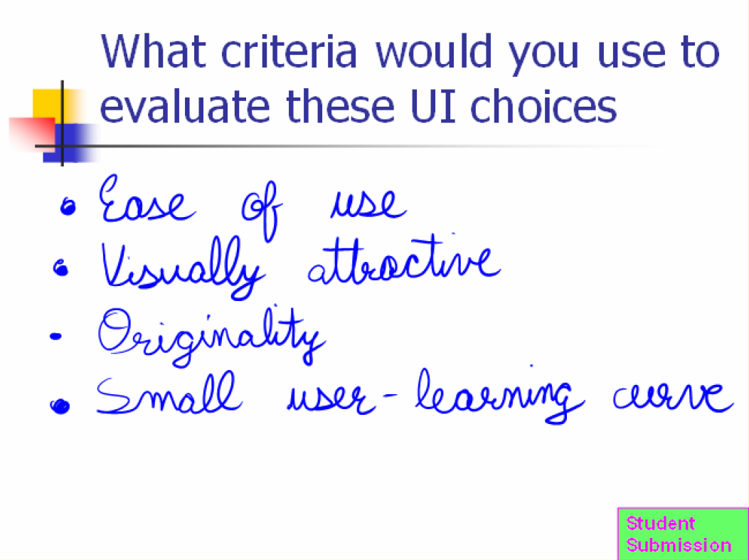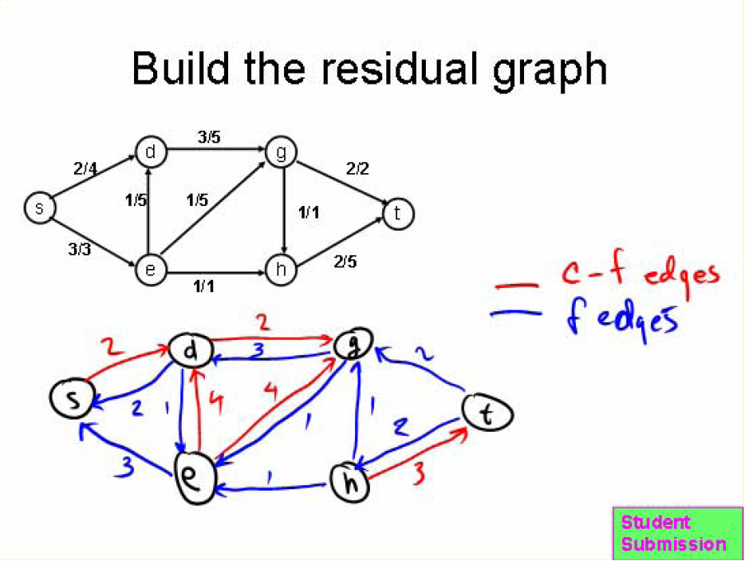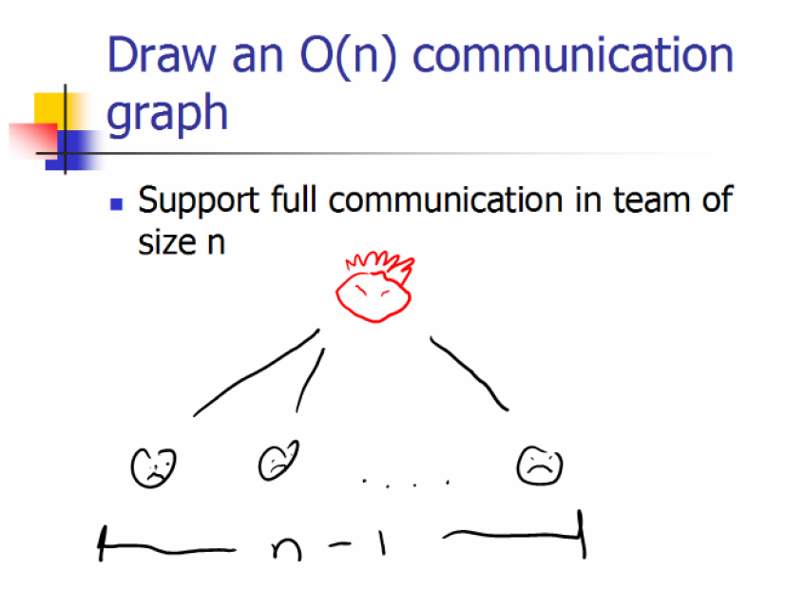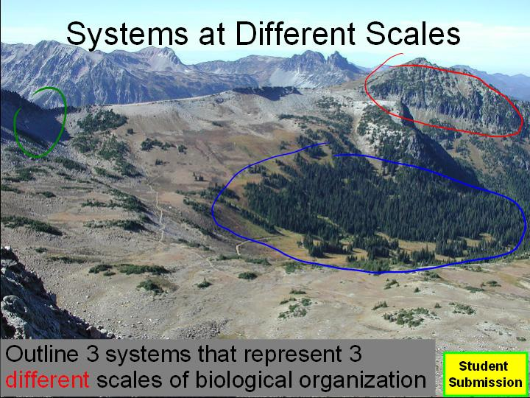
Figure 2. Examples of student responses to classroom activities. Digital ink-based activities can include textual responses, but can also focus on richer interactions including drawing diagrams, completing partial diagrams, brainstorming, and identifying parts of a diagram or image.
This result matches my empirical observations of activities performed on the Tablet PC with digital ink. Figure 2 shows examples of various activities collected from different deployments of Classroom Presenter. Starting from the upper left and going clockwise, the first activity involves the student drawing several curves on a graph to illustrate different concepts. The second example has the students highlighting various interesting regions on a timeline. The third exercise is an example of a brainstorming activity and is fully textual. Next the students were asked to manually execute an algorithm on the given graph and draw the result. The fifth example has the students brainstorm and drawn a picture of a communications network with a given property. The final exercise was for the student to identify three regions in the image with different scales of ecosystems.
None of the activities in Figure 2 would be as effective if performed using a clicker system; and they would even be difficult to describe with just text. What makes these exercises so suited to the Tablet PC is the fact that they heavily rely on highlighting and modifying pictures or diagrams, something not enabled via clickers or multiple-choice questions. Digital ink makes modifying the diagrams and pictures as simple as drawing on top of them. This is not to say that activities using multiple-choice questions cannot have a diagram, but the fundamental difference is that the diagram is not part of the response from the student as was the case in several of the examples above.
I hypothesize that the reason that multiple-choice questions are not as effective is because students simply needs to identify the correct answer instead of create the correct answer themselves. The examples above show how ink-based exercises allow the instructor to create activities that ask the student to synthesize, analyze and evaluate concepts.

Tablet PCs as an Effective Tool for Active Learning
There are two dimensions that one could analyze Classroom Response Systems from. The first is to look at the form factor of the devices used to support activities in the classroom. These range from laptops and Tablet PCs – with large screens and rich input – all the way down to mobile phones and clicker devices – supporting only simple feedback. The second dimension would be to view CRSs via the types of activities that they afford. On one end is the rich digital ink/diagrammatic interactions and activities described in section 4 and on the other end are simple multiple choice and short answer-type activities. These dimensions are in no way independent – in general those devices with large form factor have chosen to support richer activities than those CRSs targeting handheld devices. I have chosen to address CRSs as two separate groups: (i) those that use the Tablet PC (or other digital ink device) and therefore support rich forms of responses such as those involving diagrams; and (ii) those that utilize mobile/handheld devices.
Tablet PCs have been effectively shown to allow for diagrammatic activities in class and thus work well as the device for CRSs. Instructor and student responses to these systems have been overwhelmingly positive [4][9].

Classroom Presenter
Classroom Presenter is one CRS that takes a rich approach to student activities [4][6][7][49]. It is also the system that has been the focus of my research so far. Classroom Presenter as a whole is a presentation tool for delivering slide-based lectures while allowing for digital ink annotations by the instructor on the slides. Additionally, Classroom Presenter supports the networked integration of student Tablet PCs to support student activities. Student activities follow the “peer instruction” model described above. Figure 3 shows the instructor’s interface for Classroom Presenter. Only the current slide is displayed to the students, the filmstrip on the right
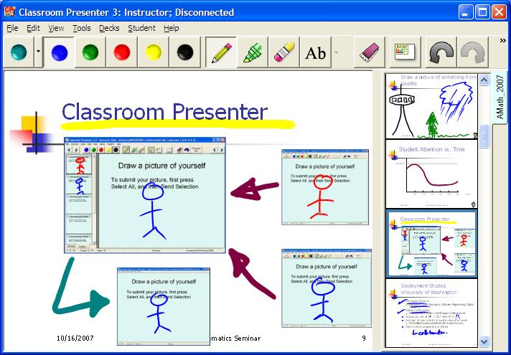
Figure 3. The Classroom Presenter interface. This shows the instructor interface, with a filmstrip view of a slide deck on the right, a toolbar on top, and the main slide view in the center. This interface is designed for use on the Tablet PC via a stylus. Classroom Presenter supports using digital ink to draw directly on slides.
allows the instructor to maintain context within the lecture and also to browse student responses that he/she receives.
The instructor can write directly on the slide and can navigate the deck and change slides by clicking on the filmstrip view. To give students an activity the instructor simply navigates to the slide with the activity. The students can then complete the activity by writing on their own Tablet PCs and then submit the slide back to the instructor. The submitted slides are collected in the filmstrip where the instructor can view them and selectively display them on the public display for discussion.
As a CRS, Classroom Presenter (CP) has many features that are beneficial. Anderson et al. [5] cite several reasons for this success:
- CP encourages all students to participate in class because shy students are given a chance to contribute; and responses are anonymous so students do not need to worry about “getting the right answer”.
- CP allows the instructor to integrate student work into the class by selectively displaying student responses. These responses can be used to show common misconceptions or highlight different techniques for solving an exercise.
- CP keeps students active and engaged in the lecture material.
- CP helps instructors to gauge whether students understand a topic or not.
These reasons are not necessarily unique to CP and many of them can be applied to CRSs in general; however, CP has some unusual properties that make it different. First, it was a conscious decision to make the submissions anonymous even to the instructor. We believe that this is a benefit because it allows students to be completely open and free to express themselves. Because many of the exercises performed with CP are brainstorming exercises, we did not want to prevent students from trying, out of fear of making a mistake. Second, CP enables rich activities that can be used to give exercises that involve “generating” a response. This is different than multiple-choice questions which require “selecting” a response. Generative activities can discover a wider variety of student misconceptions because the instructor does not have to think about all the possible misconceptions a priori (and make them choices in a multiple-choice activity). Finally, the decision was made to have the instructor be the mediator for displaying student responses on the public display since not all responses may have learning value.
Despite the benefits of Classroom Presenter there are some drawbacks. First, CP focuses on using Tablet PCs – a homogeneous set of student devices. This limits the deploy-ability of the system since most classrooms do not have a set of Tablet PCs to use. The second drawback is that it is difficult for instructors to deal with large numbers of student responses. Because each response is rich, it takes time for the instructor to assimilate the response, determine if it is correct or not, and if not, to figure out what the student did wrong. Additionally, because the exercises are more complex it is difficult to aggregate responses to determine things such as how much of the class got the exercise correct or how many made a particular mistake.

Other Tablet-Based Systems
There are a couple other systems that are similar to Classroom Presenter. The closest system is DyKnow [9][22]. It supports giving presentations via a Tablet PC, and also has support for student activities. The primary difference between DyKnow and the other CRSs described in this section is that DyKnow has a pull model where the instructor has complete control over when he/she can collect responses from the students. This allows for an instructor to “spy” on a student’s progress, or to display a student’s tablet on the public display as he/she completes an activity. This lack of anonymity leads to a different usage of DyKnow, which is much more focused on assessment than in Classroom Presenter.
GroupScribbles [10] is another system that attempts to integrate student activities into the classroom. While GroupScribbles does focus on digital ink activities, GroupScribbles does not have the students submit entire slides with a solution. Instead a student submits “post-it” notes with his/her solution and is then able to place his/her note on the submission slide as appropriate.
There are several interesting points to note about the way that GroupScribbles does student activities. First, the system makes it easy for both the instructor and other students to see all the responses to the system. Second, the activities the authors used the system for are designed to have many different subtasks to be completed by different students. The use of a single shared display allows all of the sub-results to be easily aggregated into a “big picture”. Third, voting is more naturally supported than in CP by allowing students to place their notes on the slide over the appropriate choice. It then becomes easy to aggregate the results by looking to see which item has the most notes on it. It also becomes easier to do more flexible forms of voting such as placing votes on multiple items or ranking items.
Brecht et al. also identify several pedagogical goals that they designed GroupScribbles to achieve:
- “Positive interdependence and individual accountability”: Making people feel as if their contribution matters, and that they are able to see the effects of their submission.
- “Role specialization”: Allowing different students to perform different parts of a task.
- “Even-odd Tolerance”: Allowing groups to have either an even or odd number of students.
- “Support for Differential Rates of Completion”: Allowing for some students to complete a task faster than others, and ensuring that those students are kept engaged.
The authors show how the different types of student activities supported by GroupScribbles can achieve these goals. As mentioned above, larger tasks can be divided amongst students allowing everyone to be responsible for a part of the whole activity. The students then get to see their contribution on the public display. Also, most of the activities do not depend on having a specific number of people. Lastly, because the activities have several subtasks faster students can perform more subtasks if they finish early.
LiveNotes has many similarities to the other systems mentioned here. It is a Tablet PC-based application in which the instructor’s slides are sent to the students. The student can write on the slides and share this ink with others. However, LiveNotes is not a true CRS because (i) the instructor does not provide planned activities, (ii) there is no submission of activities to the instructor, and (iii) there are no activities to discuss amongst peers and integrate into the lecture. Instead LiveNotes is a “peer instruction” tool that uses note-taking instead of student exercises.

Handheld Devices for Student Exercises
Devices that support student exercises are not limited to the rich digital ink domain of Tablet PCs. Handheld devices have also been used in exploring Active Learning via CRSs. Most of the work has focused on simple multiple-choice response systems (such as Clickers) or simple textual input (for example using SMS).
The motivations behind using these handhelds in the classroom are two-fold. First, the cost of expensive laptops or Tablet PCs makes it impractical to require them for each student (or even per group of students). Also, it is impractical to have a “classroom set” of Tablet PCs because the cost of maintaining and setting them up would be prohibitive, we have found this to be true in our deployments of Classroom Presenter. The second argument given for using handheld devices in the classroom is that these devices are more portable and easier for students to carry. I would argue that for many students there is a third requirement necessary for a device to be accepted by students. I believe that the device must also be useful outside of the classroom.
Clicker systems have been around for a while as a handheld device for engaging students in Active Learning [12][21]. Most clicker systems require each student to purchase a specialized piece of hardware that is very similar to a television remote control. This device can then communicate wirelessly to a sensor in the classroom that records the button pressed by the student on the device. The instructor can use these systems to poll the students in the classroom. The software included with the system allows for quickly building histograms of student responses and displaying them to the instructor. Most Clicker systems also support the registration of student devices and can be used to record whether students respond to questions and what their response is. This fundamentally differs from the model used by Classroom Presenter which uses anonymous submissions. This can lead to clickers being used for taking attendance rather than for Active Learning.
Clickers meet the cost requirement for handheld devices – costing around $25 each (the most expensive costing $50 before rebate) [21]. These devices are also small which makes them very portable. However, these clickers do not have any use outside of the classroom which makes them just another thing to remember to bring to class. Because of this issue and the limitations of the device itself researchers have attempted to utilize mobile phones and PDAs for student exercises.
The Pebbles project [39] at CMU is a large project that has been concerned with using a handheld PDA as a secondary display to augment a traditional computer monitor. This was primarily concerned with un-tethering the lecturer from his/her laptop and allowing him/her the ability to interact with the audience more freely. However, part of the project also focused on using the system to give students multiple choice tests about the lecture to ensure that he or she understood the concepts [14]. In this way the use of Pebbles was much like the use of Clickers; however, the Pebbles framework has the potential to allow for much greater input than simple multiple choice responses [40]. Namely, Pebbles supports rich collaboration between multiple PDAs that could be used for “peer instruction” and other types of student exercises in the classroom.
Along these same lines is the ActiveClass project [46]. This is part of the larger ActiveCampus project at UCSD [26]. The purpose of this project is to build a network on the campus to support education. There are several initiatives as part of ActiveCampus, but only ActiveClass is relevant to classroom activities and Classroom Response Systems. Like most of the other systems discussed previously ActiveClass is a software program for use on PDAs in order to allow students to ask questions and give feedback to the instructor, but it also allows answering of polls initiated by the instructor. The difference between ActiveClass and other systems is that ActiveClass allows students to see the results of polls directly on their PDA at any time instead of relying on the instructor to display the results at the end of the poll. Also, the system has a voting mechanism for student-asked questions where other students can see the current questions and vote on those that they wants answered as well.
Perhaps the system which provides the closest experience to the systems in section 5 is Classtalk [20]. Classtalk is a system designed to be used via PDAs or graphing calculators and supports multiple-choice, short-answer, and numerical responses. The biggest benefit of Classtalk is its ability to aggregate responses automatically. Classtalk was also one of the first pieces of work to integrate the classroom response system into the “peer instruction” methodology. The authors developed the “question cycle” where the instructor asks a question, the students work cooperatively and submit answers, the answers are aggregated and discussed and then the cycle continues. Though Classtalk uses portable handheld devices in the classroom it is not a very feasible solution – the system requires special infrastructure within the classroom to communicate to the student devices.
Because of the difficulty of deploying the above solutions, people have also explored the use of SMS for in-class communication and activities. Markett et al. developed PLS TXT UR Thoughts [37], an application to interpret SMS messages from student mobile phones in order to support in-class activities and also anonymous questions for the instructor. One major benefit of the system was that it used the cellular network requiring no infrastructure to be in place in the classroom. However, the use of SMS does incur an additional per-use charge to the student. Also, the interaction is limited to the length of an SMS message (160 characters). One issue with this work is that the authors only used the system to allow students to ask questions about the lecture not for classroom activities. Still, the approach is promising.
Another piece of work focusing on mobile phones in the classroom was done by Lindquist et al. to extend Ubiquitous Presenter to mobile phones [36]. This work looked at how one might use mobile phones to give the ability to allow students to respond to multiple choice questions, short answer questions, or even the ability to take a photograph of a more complex response and send the photo to the instructor. This use of the camera is novel and holds great potential for using handheld devices for richer types of activities (despite their limited input).
Table 1. Summary of Classroom Response Systems. This table summarizes the key features of the systems described in sections 5 and 6.
System Name | Form Factor | Features
Classroom Presenter | Tablet PC, Laptop | Rich submission model  Digital ink input  Slide-based activities  Anonymous submissions
Ubiquitous Presenter | Web browser | Works on any device with a web browser  Supports many Classroom Presenter features
DyKnow | Tablet PC, Laptop | Rich submission model  Part of a large system of classroom technology  Slide-based activities  High degree of instructor control over student submissions
GroupScribbles | Tablet PC, Laptop | Supports editing and moving of submissions  Encourages multiple submissions per student  Multi-part activities  Post-it-based activities
Clickers | Custom Hardware | Small  Affordable  Supports hundreds of simultaneous students  Multiple-choice responses only  Not anonymous
Classtalk | PDA | Multiple-choice responses  Short-answer responses  Numeric responses
Pebbles | PDA | Question asking  Multiple-choice responses  Multi-device framework for building applications
Geney | PDA | Single, collaborative activity  Different interfaces per group members
ActiveClass | PDA | Question asking  Voting on questions  Multiple-choice responses  Results always available
PLS TXT UR Thoughts | Mobile Phone | Recurring SMS cost  Limited input (160 characters)
Ubiquitous Presenter (Mobile) | Mobile Phone | Camera-based responses  Short-answer responses  Recurring SMS cost
There have been numerous other systems that have tried to use handhelds to engage students in the classroom. However, most of these attempts have focused on building an application with a specific activity hard-coded into it for use on the handheld devices. While these applications have utilized both graphing calculators [17] as well as PDAs [35][43][53][55], because we are interested in general frameworks for promoting classroom interaction (specifically CRSs) we will not focus on them in this paper. However, one system worth mentioning is Geney [47] a research application used to explore collaboration between children in the classroom. Geney is an interesting application because not all of the student’s interfaces within a group were the same, i.e. students who are in the same group will see different information on their PDA. This design choice was made to encourage collaboration, but it raises the question of whether or not all students need to have the exact same interface when given a student exercise.
While there has been much done with handheld devices in the classroom, there seems to be a large gap still between the experience on the Tablet PC – making large use of digital ink – and the community focusing on portable, low-cost solutions. Table 1 summarizes the differences between the systems described in the past two sections.

Remaining Challenges
I have discussed the educational benefits of Active Learning and I have shown how CRSs have been used successfully to engage students in Active Learning. Yet there has not been a huge penetration of these systems in the classroom. I hypothesize that there are two reasons for this. First, I believe that the simpler, handheld systems do not have enough interactivity to justify the cost of deploying them. Second, the richer digital ink systems are also too expensive to justify their cost despite the richer activities they enable. Therefore, the solution is to either (i) increase the types of activities supported by handheld devices, or (ii) to reduce the cost of deploying the system by using the devices that students already own. I choose to explore both of these solutions simultaneously with the hopes of creating a system with better support for rich activities across handheld devices while also lowering the cost by utilizing student owned devices!
I will discuss the proposed work toward both of these challenges in the next section, but first I will explore some previous work that has been done on utilizing multiple input device types in the classroom. There are three major pieces of work that have addressed this issue. Liao et al. [34] has done work with comparing students using the Anoto Pen technology with Tablet PC technologies in Classroom Presenter. In this work, the authors tried to emulate many of the features of Classroom Presenter’s Tablet PC interface by printing out physical presentation slides and using the Anoto Pen on top of these slides. The Anoto Pen technology looks like a normal pen, but can digitally record real handwriting on physical paper. This work was able to successfully integrate these two different technologies into the classroom.
Work has been done to extend the Ubiquitous Presenter interface to mobile phones as described above [36]. This is another example of attempting to integrate multiple types of input modalities into the classroom. The system supports both textual and camera-based submissions and can work along-side existing Ubiquitous Presenter clients on Tablet PCs or laptops. One issue that arose is an envy effect toward the students using the Tablet PCs. This is an issue that will only get worse as the set of devices in the classroom increases.
Denning et al. [18] compared the use of text-based input to digital ink input when comparing laptops to Tablet PCs as input devices. This work showed that some exercises were very difficult with text (those that involved describing locations on a slide or drawing diagrams), while other were less burdensome – for example, identifying several positions on a number line. We can conclude from this that certain types of activities might be easier or harder depending on the available input modalities.

Proposed Work
The following section outlines my proposed thesis work toward completing my dissertation. The first contribution of my work is to develop methods for utilizing handheld devices to emulate the types of diagrammatic activities enabled on Tablet PC devices. The second contribution of my work is to develop tools and design guidelines for integrating a diverse set of student owned devices into the digital classroom. Achieving these goals involves understanding the following issues:
- How to provide rich interaction on devices with limited capabilities; and determine what the limits are for different devices,
- How to combat envy effects and conflicts amongst students with different devices,
- How to design classroom activities for a diverse set of devices,
- How to assist the instructor with dealing with responses from a diverse set of devices, and
- How to evaluate the effectiveness of Classroom Response Systems when there are a diverse set of devices in the classroom.

Examine the Effects of Heterogeneous Devices in the Classroom
Dealing with a heterogeneous set of devices is a challenging prospect. Consider the generic problem of designing an interface for an activity. What screen size should you optimize your interface for? Figure 4 shows a scatter plot of physical width versus height for a large range of devices. We can see that for laptops and larger devices there are two distinct groups that correspond to monitors of aspect ratio 4:3 and 16:9. However, as we get smaller screens, such as those on cellular phones we find that there are not two distinct aspect ratios in fact there are many different aspect rations as well as many different physical screen sizes. This combined with the fact that the screen is so small already makes it challenging to generalize any interface or activity to a large set of devices.
Figure 4. Diagram showing physical screen sizes of various devices [15][41].
There are a couple of potential solutions to this dilemma to be explored. First we can use a tool such as SUPPLE to automatically adjust ones activity to different screen sizes, optimizing the interaction for the capabilities and form factor of the device [24]. This has the advantage that the interface would be tuned to the device; however, there is the disadvantage that it simply may not be possible to adjust the interface to a device. Another option is to instead have a uniform “virtual” activity size and then to use zooming techniques to allow the user to interact with this virtual canvas on a small screen. This has the advantage of lowering the burden on the activity creator, but has the disadvantage of being limited by the capabilities of the zooming technique used. I plan to test both of these techniques in my work.
Additionally I will look for techniques for making certain classes of student activities accessible on different devices. One student activity style used on the Tablet PC is to have the students identify parts of an image. While this can be done on the Tablet PC by circling the image using digital ink, there is no reason that this could not be supported with other devices. Students could instead navigate a marker around the screen with a directional pad or select a region using a mouse or analog joystick. Furthermore, even the creation of diagrams is possible without a stylus by using pre-defined shapes and lines. I will explore several of these possibilities for mobile devices.
The second question I hope to answer looks at learning effects of having students with different devices in the classroom. As mentioned in the previous section there is the possibility of student envy effects. How does the device a person uses affect not only his/her performance at a task, but also his/her enjoyment? Can envy effects be used to engage students in class? How do you mitigate envy effects? One solution might be to swap or share devices within groups. Another solution may be to choose a set of activities for each class period, each of which favors different device types.
Also, there is a need to examine how students can cooperate and engage in “peer instruction” when they have multiple devices. Can exercises effectively be split between users? What type of activities are effective for cooperative learning over different devices and which are not?

Building a Taxonomy of In Class Activities
Although the education literature has done much work building taxonomies for student activities, no such taxonomy exists for Classroom Response System activity types. In [10] the authors identified 41 distinct activity patterns from their work and [19] identified another set of activity patterns. Also, in our previous work we have informally identified a set of activity patterns. Using these different sources I propose creating a taxonomy of common CRS activities and also compiling a set of benchmark activities that can be used to study the performance and capabilities of different Classroom Response Systems.
Table 2 lists a set of input modalities and the classes of devices that support these input modalities. These input modalities will be a basis for determining which activities are best suited to which devices. This can then be used as a basis for determining how to adapt different devices to different activities. It can also serve as a basis for informing the instructor as to what activities are most appropriate for his/her class. Furthermore for each of these input modalities there may be other factors which might affect the usability for the devices. For example, while a PDA might have a full keyboard it is still more difficult to type on a small device than on a full-sized keyboard. Exploring this area will also involve exploring issues such as these. Also, I can explore how efficient or inefficient people are at using different interfaces for different activities and how accurate they are. One study I would like to perform is to explore performance on non-textual generative tasks over different devices with different input modalities – for example, comparing redrawing a diagram freehand versus using predefined shapes. The result of this work will be a tool to assist instructors in creating exercises suited to the devices in their classrooms.
Table 2. Hardware input modalities and Example Devices
Input Modality (Hardware) | Example Mobile Devices
Keyboard | Laptop, Tablet PC (hybrid)
Keypad | Mobile Phone
Directional Pad (2-way, 4-way, or 8-way) | Mobile Phone, PDA, Gaming Device
Mouse | Laptop (external)
Trackball | Laptop (external)
Touchpad (relative motion only) | Laptop
Joystick | Gaming Device
Accelerometer | Mobile Phone, PDA
Stylus/Pen | Tablet PC, PDA
Touch-screen | iPhone, Tablet PC (some)
Camera | Mobile Phone, iPhone

Accompanying this work would be user studies looking at what types of activities keep the students most engaged and lead to the greatest learning outcomes. It may be possible to identify which patterns are most common and use this data to assist an instructor in designing activities that are most suited to his or her classroom.

Tools for Helping Instructors Deal with Heterogeneous Devices
Given the results from the studies above I propose creating a set of tools to aid instructors in dealing with heterogeneous student devices in the classroom. One major challenge of having heterogeneous devices in the classroom is that different activities are more or less suited to different devices. I hypothesize that although there may be these effects amongst different devices that some of these effects can be mitigated by balancing the activity types amongst the different devices in the classroom.
Another potential way to target multiple devices it to encode classroom activities with additional metadata in order to aid in automatically translating activities into forms that are suitable for a range of devices. For example, while it may not be directly possible for a student to draw out or modify an image of a graph using digital ink on his/her handheld, if the graph were in a machine readable form, then the student could use their numeric keypad to navigate around the graph and make changes to it.
Having tools to author activities for heterogeneous devices is not enough though. I also propose related work that would look at tools for allowing instructors to deal with multiple modalities of student submissions. The proposed solution here is again to rely on a higher-level language for specifying activities so that there is metadata associated with activities for different devices. This provides a common framework across different devices and submission modalities to unify them. To illustrate the difficulties of this problem consider dealing with the problem of trying to compare a drawn image of a Tic-Tac-Toe board with the textual representation of the board. If you have no idea that you are dealing with Tic-Tac-Toe then this becomes nearly impossible; however, if the instructor specifies that there is 3x3 grid of squares and each has an X or O within it – specified from top to bottom, left to right – then interpreting and unifying these two representations becomes feasible.
I have already done some work related to clustering student responses [45]. However, in this work I was focused solely on clustering student responses in Classroom Presenter. These were only ink-based responses and were all from the Tablet PC. Although these were homogeneous devices many of the same difficulties arose here as I believe would arise with heterogeneous student devices. Namely, that there is ambiguity in how students decide to respond to student activities and how they structure their responses. With metadata, something not available in [45], I hope to be able to solve this issue.

Evaluation Metrics
Finally, in order to evaluate my work it will be necessary to explore various evaluation metrics. Developing good metrics for Classroom Response Systems is a difficult task because it is 1) difficult to isolate factors in the classroom without hindering the learning environment, and 2) time consuming to do extensive in-class studies of technologies.
There are three popular methods used to evaluating these systems. First, there are qualitative case studies. These are the least controlled and have many outside factors that can skew the results; however, they are arguably the most informative. Second are controlled classroom studies. These controlled studies usually only focus on a single classroom and a limited number of sessions. And this metric can be used to compare a small number of conditions side-by-side; however, it is hard to generalize any conclusions because you need to fix a set of parameters for the classroom beforehand which may favor one condition over another. Third are lab studies. Lab studies are the rarest in the literature because they are seen as the least realistic. However, lab studies can be finely controlled and are usually much shorter term than the other evaluation metrics. Therefore, lab studies have the potential to test more conditions than the other types of evaluations.
In my work I hope to apply each of the types of evaluation and explore the effectiveness of each. I also hope to come up with new metrics based on my taxonomy of common activities. There activities can use used as a benchmark for user studies to compare different conditions against one another.

Conclusion
In this work I have tried to show that Active Learning is a much better pedagogy than the traditional lecture based class. Classroom technology is able to assist lecturers in creating a more engaging and active environment. One successful way to do this is through the use of Classroom Response Systems. I have shown that there are two main types of Classroom Response Systems: those that rely on relatively large and expensive hardware (namely Tablet PCs) to support digital ink input and rich interaction and those that rely on inexpensive handheld and mobile technologies. While the handheld devices are certainly more feasible despite their inferior expressive power, they have still not been adopted because Classroom Response Systems all depend on having a homogeneous set of devices.
In order to successfully have Classroom Response Systems adopted one needs to leverage the mobile devices that students already own and already carry around with themselves everywhere to build one’s system. However, this raises many challenges:
- How to combat envy effects and conflicts amongst students with different devices,
- How to provide rich interaction on devices with limited capabilities; and determine what the limits are for different devices,
- How to design classroom activities for a diverse set of devices,
- How to assist the instructor with dealing with responses from a diverse set of devices, and
- How to evaluate the effectiveness of Classroom Response Systems when there are a diverse set of devices in the classroom.
In my thesis work I hope to provide answer for these challenges so that it is possible to successfully integrate a diverse set of student devices into the classroom – in order to support Active Learning and improve education.

References
- Abowd G. D. “Classroom 2000: An experiment with the instrumentation of a living educational environment”. IBM Systems Journal, 38(4) 508-530, 1999.
- Abowd G. D., Atkeson C. G., Brotherton J., Enqvist T., Gulley P., LeMon J. “Investigating the Capture, Integration and Access Problem of Ubiquitous Computing in an Educational Setting”. CHI '98: Proceedings of the SIGCHI conference on Human factors in computing systems, 1998.
- Abrahamson A. L. “Teaching with Classroom Communication System – What it Involves and Why it Works”. Mini-Course presented at the VII Taller Internacional "Nuevas Tendencias en la Ensenanza de la Fisica". Puebla, Mexico, May 27-30, 1999.
- Anderson R. J., Anderson R., Davis K. M., Linnell N., Prince C., Razmov V. “Supporting Active Learning and Example Based Instruction with Classroom Technology”. SIGCSE ’07, 2007.
- Anderson R., Anderson R.E., Linnell N., Razmov V. “Supporting Structured Activities and Collaboration through the Use of Student Devices in College Classrooms”. Available at http://classroompresenter.cs.washington.edu/papers/2006/AALR_2006.pdf.
- Anderson R. J., Anderson R., Simon B., Wolfman S. A., VanDeGrift T., Yasuhara K. “Experiences with a Tablet PC Based Lecture Presentation System in Computer Science Courses”. SIGCSE '04: Proceedings of the 35th SIGCSE technical symposium on Computer science education, pp. 56-60, 2004.
- Anderson R. J., Hoyer C., Wolfman S. A., Anderson R. “A Study of Digital Ink in Lecture Presentation”. CHI '04: Proceedings of the SIGCHI conference on Human factors in computing systems, 2004.
- B & H: Photo – Video – Pro Audio. http://www.bhphotovideo.com/c/shop/3718/Digital_Whiteboards_Wall_Displays.html.
- Berque D., Bonebright T., Whitesell M. “Using Pen-Based Computers Across the Computer Science Curriculum”. SIGCSE '04: Proceedings of the 35th SIGCSE technical symposium on Computer science education, pp.61-65, 2004.
- Brecht J., DiGiano C., Patton C., Tatar D., Chaudhury R., Roschelle J., & Davis K. (in press). “Coordinating networked learning activities with a general-purpose Interface”. To appear in the International Review of Research in Open and Distance Learning.
- Buckalew C., Porter A. “The Lecturer’s Assistant”. SIGCSE '93: Proceedings of the 24th SIGCSE technical symposium on Computer science education. 1993.
- Burnstein R. A., Lederman L. M. “Using Wireless Keypads in Lecture Classes”. The Physics Teacher. 39(1):8-11, 2001.
- Campbell A. B., Pargas R. P. “Laptops in the Classroom”. SIGCSE '03: Proceedings of the 34th SIGCSE technical symposium on Computer science education, pp. 98-102, 2003.
- Chen F., Myers B., Yaron D. “Using Handheld Devices for Tests in Classes”. Carnegie Mellon University Department of Computer Science Tech. Rep. CMU-CS-00-152. Available at http://www.cs.cmu.edu/~pebbles/papers/CMU-CS-00-152.pdf.
- CNet.com. http://reviews.cnet.com.
- Davis R. C., Landay J. A., Chen V., Huang J., Lee R. B., Li F. C., Lin J., Morrey III C. B., Schleimer B., Price M. N., Schilit B. N. “NotePals: Lightweight Note Sharing by the Group, for the Group”. CHI '99: Proceedings of the SIGCHI conference on Human factors in computing systems, 1999.
- Davis S. “Observations in classrooms using a network of handheld devices”. Journal of Computer Assisted Learning, Vol. 19, pp. 298-307, 2003.
- Denning T., Griswold W. G., Simon B., Wilkerson M. “Multimodal Communication in the Classroom: What does it mean for us?”. SIGCSE '06: Proceedings of the 36th SIGCSE technical symposium on Computer science education, pp. 219-223, 2006.
- DiGiano C., Yarnall L., Patton C., Roschelle J., Tatar D., Manley M. “Conceptual tools for planning for the wireless classroom”. Journal of Computer Assisted Learning, Vol. 19, pp. 284-297, 2003.
- Dufresne R. J., Gerace W. J., Leonard W. J., Mestre J. P., Wenk L. “Classtalk: A Classroom Communication System for Active Learning”. Journal of Computing in Higher Education, 7, 3-47, (1996).
- Duncan D. “Clickers: A New Teaching Aid with Exceptional Promise”. Astronomy Education Review, 5(1), 2006.
- DyKnow. http://www.dyknow.com.
- Englebart D., English W. K. “A Research Center for Augmenting Human Intellect”. Proceedings of Fall Joint Computing Conference, 395-410. AFIPS Press, Vol. 33, 1968.
- Gajos K., Weld D. S. “SUPPLE: Automatically Generating User Interfaces”. In Proceedings of IUI'04, 2004
- Golub E. “Handwritten Slides on a TabletPC in a Discrete Mathematics Course”. SIGCSE '04: Proceedings of the 35th SIGCSE technical symposium on Computer science education, pp.51-55, 2004.
- Griswold W. G., Shanahan P., Brown S. W., Boyer R. T. “ActiveCampus – Experiments in Community-Oriented Ubiquitous Computing”. IEEE Computer, 36(10) 73-81, 2004.
- Hake R. “Interactive-engagement Versus Traditional Methods: A Six-thousand-student Survey of Mechanics Test Data for Introductory Physics Courses”. American Journal of Physics, 66 (1), Jan. 1998.
- Iles A., Glaser D., Kam M., Canny J., Do E. “Learning Via Distributed Dialogue” Livenotes and Handheld Wireless Technology”. Final Report for the Center of Innovative Learning Technologies (CILT).
- Iles A., Kam M., Glaser D. “Dimensions of Identity in Open Educational Settings”. In Adjunct Proceedings of the 5th International Conference on Ubiquitous Computing, pp. 175-176, 2003.
- Kam M., Tarshish O., Glaser D., Iles A., Canny J. “Communicating through Handheld Wireless Tablets: Livenotes and Shared Group Awareness”. In Supplemental Proceedings of ACM Conference on CSCW '02, 2002.
- Kam M., Wang J., Iles A., Tse E., Chiu J., Glaser D., Tarshish O., and Canny J. “Livenotes: A System for Cooperative and Augmented Note-Taking in Lectures”. CHI 2005.
- Kiewra K. A., DuBois N. F., Christian D., McShane A. “Providing Study Notes: Comparison of Three Types of Notes for Review”. Journal of Educational Psychology, 80(4) 595-597, 1988.
- Koschmann T. “Toward a Dialogic Theory of Learning: Bakhtin’s Contribution to Understanding Learning in Settings of Collaboration”. Proceedings of the 1999 conference on Computer support for collaborative learning, 1999.
- Liao C., Guimbretiere F., Anderson R., Linnell N., Prince C., Razmov V. “PaperCP: Exploring the Integration of Physical and Digital Affordances for Active Learning”. INTERACT ‘07, 2007.
- Lin S., Tatar D., Harrison S., Roschelle J., Patton C. “Learning When Less is More: ‘Bootstrapping’ Undergraduate Programmers as Coordination Designers”. Proc. Participatory Design Conf., ACM Press, pp. 133–136, 2006.
- Lindquist D., Denning T., Kelly M., Malani R., Griswold W. G., and Simon B. “Exploring the Potential of Mobile Phones for Active Learning in the Classroom”. SIGCSE ’07: Proceedings of the 38th SIGCSE Technical Symposium on Computer Science Education, March 2007.
- Markett C., Sanchez I. A., Weber S., Tangney B. “Using short message service to encourage interactivity in the classroom”. Computers & Education, 46 280-293, 2006.
- Mazur, E. Peer Instruction: A User's Manual. Prentice-Hall, New Jersey, 1997.
- Myers B. A. “Using Hand-Held Devices and PCs Together”. Communications of the ACM. Volume 44, Issue 11. November, 2001. pp. 34 – 41.
- Myers B. A., Stiel H., Gargiulo R. “Collaboration Using Multiple PDAs Connected to a PC”. In Proceedings of CSCW’98, 1998.
- Newegg.com. http://www.newegg.com.
- Penuel W. R., Roschelle J., Abrahamson L. “Research on classroom networks for whole-class activities”. WMTE '05: Proceedings of the 3rd IEEE International Workshop on Wireless and Mobile Technologies in Education, 2005.
- Penuel W. R., Yarnall L. “Designing Handheld Software to Support Classroom Assessment: An Analysis of Conditions for Teacher Adoption”. The Journal of Technology, Learning, and Assessment, 3(5), February 2005.
- Ploetznerl R., Dillenbourg P., Praier M., Traum D. “Learning by Explaining to Oneself and to Others”. In P. Dillenbourg (ed) Collaborative-learning: Cognitive and Computational Approaches, pp. 103-121, 1999.
- Prince C. “Using Clustering to Assist Understanding of Digital Ink in Low Attention Environments”. Qualifying Examination Document, Autumn 2005, Available at: http://www.cs.washington.edu/homes/cmprince/papers/CmprinceQualsDocument.pdf.
- Ratto M., Shapiro R. B., Truong T. M., Griswold W. G. “The ActiveClass Project: Experiments in Encouraging Classroom Participation”. Computer Support for Collaborative Learning, 2003.
- Regan L., Mandryk, Inkpen K. M., Bilezikjian M., Klemmer S. R., Landay J. A. “Supporting Children’s Collaboration Across Handheld Computers”. CHI '01: CHI '01 extended abstracts on Human factors in computing systems, 2001.
- Scardamalia M., Bereiter C. “Text-Based and Knowledge-Based Questioning by Children”. Cognition and Instruction, 9(3) 177-199, 1992.
- Simon B., Anderson R., Hoyer C, Su J. “Preliminary Experiences with a Tablet PC Based System to Support Active Learning in Computer Science Courses”. ITiCSE '04: Proceedings of the 9th annual SIGCSE conference on Innovation and technology in computer science education, pp. 213-217, 2004.
- Singh G., Denoue L., Das A. “Collaborative Note Taking”. WMTE '04: Proceedings of the 2nd IEEE International Workshop on Wireless and Mobile Technologies in Education, 2004.
- Shneiderman B., Alavi M., Norman K., Borkowski E. Y. “Windows of Opportunity in Electronic Classrooms”. Communications of the ACM, 38(11) 19-24, 1995.
- Solvie P. A. “The Digital Whiteboard: A Tool in Early Literacy Instruction”. The Reading Teacher, February 2004.
- Tatar D., Roschelle J., Vahey P., Penuel W. R. “Handhelds Go to School: Lessons Learned”. Computer, 36(9), 2003.
- Truong K. N., Abowd G. D. “StuPad: Integrating Student Notes with Class Lectures”. CHI '99: Proceedings of the SIGCHI conference on Human factors in computing systems, 1999.
- Vahey P., Tatar D., Roschelle J. “Leveraging Handhelds to Increase Student Learning: Engaging Middle School Students with the Mathematics of Change”. ICLS '04: Proceedings of the 6th international conference on Learning sciences, pp. 553-560, 2004.
- Wilkerson M, Griswold W. G., Simon B. “Ubiquitous Presenter: Increasing Student Access and Control in a Digital Learning Environment”. SIGCSE ’05: Proceedings of the 36th SIGCSE Technical Symposium on Computer Science Education. 2005.
- Wittrock M. “Generative Processes of Comprehension”. Educational Psychologist, 24(4), 345-376, 1990.

